
Arab International University
Information &Communications engineering
Microprocessors & Microcontrollers

Final Lab Project
Microprocessors & Microcontrollers

Bluetooth Control of 2LEDs
Using Arduino and Remote XY App

By: Omar Hafez Khalil || “202110479”
By: Abdulla khaled || “202111362”
By: Ali Awad || “202211036”
By:Sima abilshamat || “202120074”

G11 (Tuesday 2:00-4:00 PM)
Semester: 2024-1

Supervised by:
Eng. Maha Qubais

Table of Contents
Main idea of the project: 3
Components Used: 3
Arduino Sketch ”include library”: 4
Usage: 4
Circuit Connections: 4
How to design mobile app: 5
How to connect mobile app 9
What to do After design: 10
Source code: 10
Conclusion: 14
References: 14

Main idea of the project:
The objective of this project was to create a system that wirelessly controls the on/off state of two LEDs using switches in the Remote XY mobile app via Bluetooth. Additionally, a physical button connected to the Arduino was incorporated to toggle the displayed text on the Remote XY app between “Maha Qubais” when pressed and “2024/12/08” when not pressed.The project utilized an Arduino Mega 2560 board as the microcontroller, facilitating communication between the app and the LEDs. The Remote XY app provided a graphical user interface for controlling the LEDs.

Components Used:
- Arduino board (Arduino Mega 2560).
- Two LEDs.
- Resistors for each LED.
- Button.
- Breadboard and wires.
- Smartphone with the Remote XY app.

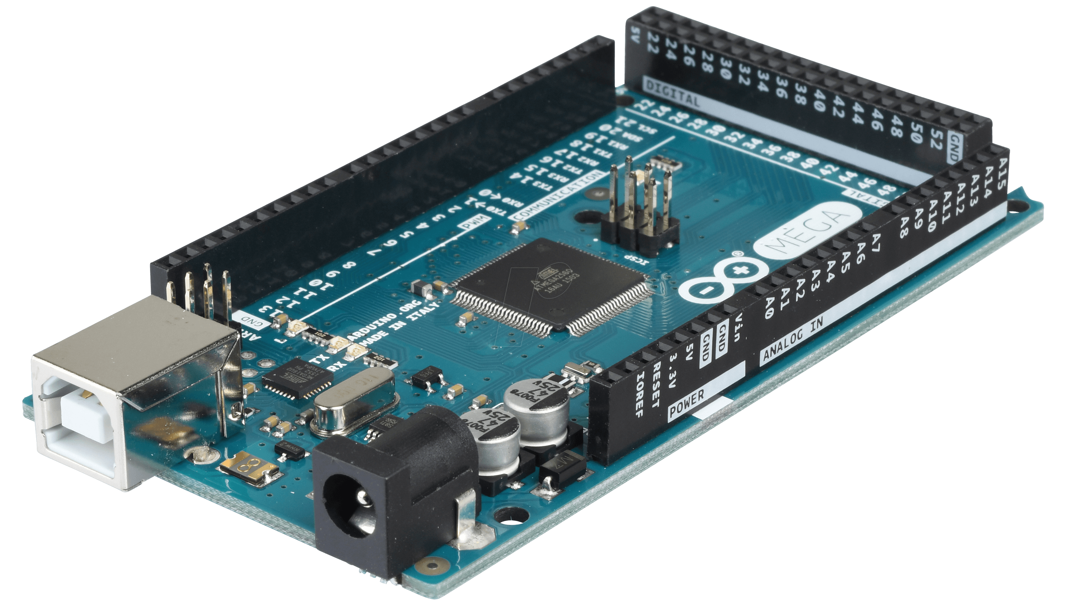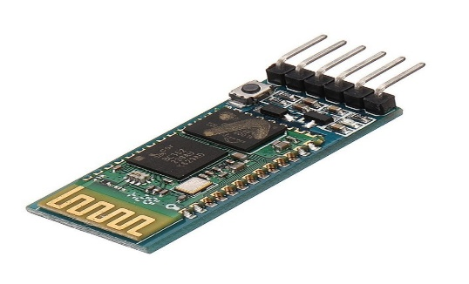

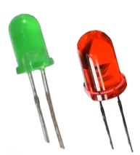
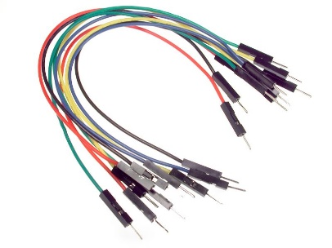
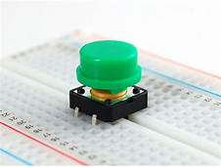

Arduino Sketch ”include library”:
The Arduino sketch for this project controls the LEDs based on the input received from the Remote XY app via Bluetooth. The sketch includes the Remote XY library for establishing communication with the app. It reads the switch states from the app and uses them to control the LEDs' on/off state. And the state of the physical push button was monitored using the digitalRead() function. When the push button was pressed, the text displayed on the Remote XY app was updated to “Maha Qubais” when pressed and “2024/12/08” when not pressed

Usage:
1. The switches in the app to turn the LEDs on or off.
2. The physical push button on the Arduino could be pressed to toggle the displayed text on the Remote XY app between “Maha Qubais” when pressed and “2024/12/08” when not pressed.

Circuit Connections:
1. The longer leg of the 1st LED was connected to digital pin 13 on the Arduino with a resistor in between.
2. The shorter leg of the 1st LED was connected to the Arduino's ground (GND) pin.
3. The longer leg of the 2nd LED was connected to digital pin 12 on the Arduino with a resistor.
4. The shorter leg of the 2nd LED was connected to the Arduino's ground (GND) pin.
5. The button was connected to a digital pin on the Arduino (pin 9) with a 10k ohms resistor, +5V pin and the Arduino's ground (GND) pin.

Bluetooth “HC-05” connections:
1-Vcc to 5v of Arduino
2-GND to GND of Arduino
3-TX to RX of Arduino in this project I use 10th pin.
4-RX to TX of Arduino in this project I use 11th pin.

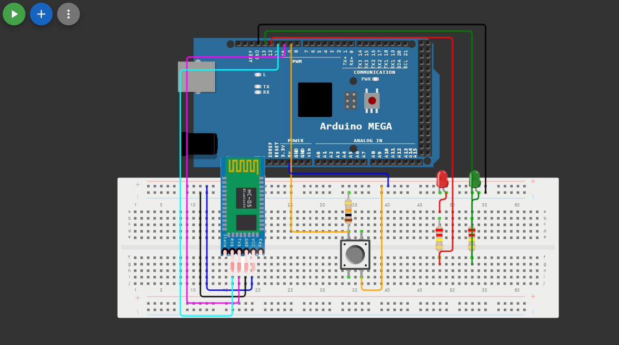
Connection diagram
Using Autodesk
tinkercad

How to design mobile app:

1-open remote xy website and start new project : https://remotexy.com/
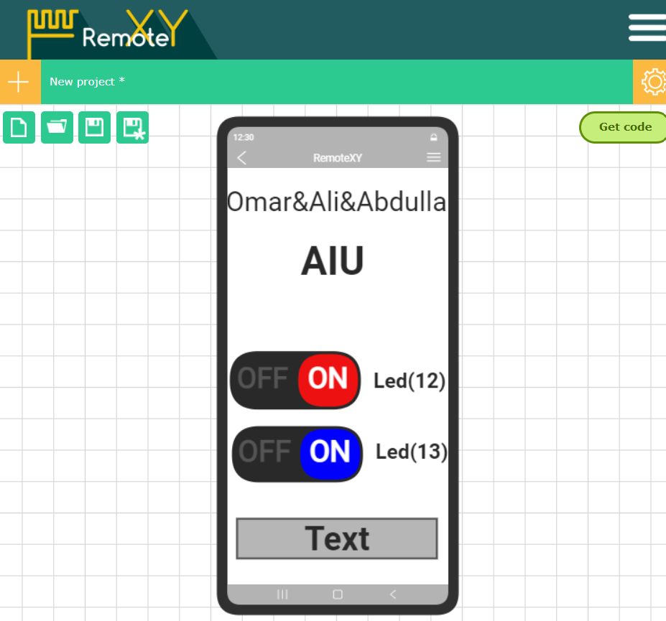

2-choose the type of your Arduino and type of connection and Bluetooth model” HC_05” and what is the application used to implement code and TX RX pins in the configuration part in the right of the design page .

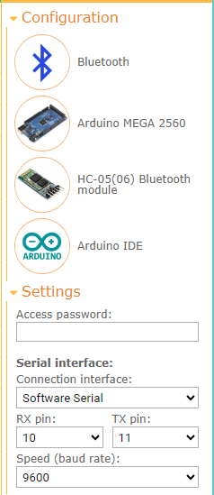

3-choose the component that you need to your project from the left of the design page from elements section.in our case we need 2 switches and 1 strings and 4 labels for typing our name and our university name and pin number for each led then for every switch choose the pin number by clicking on switch then on the right of the design page switch control part appears.

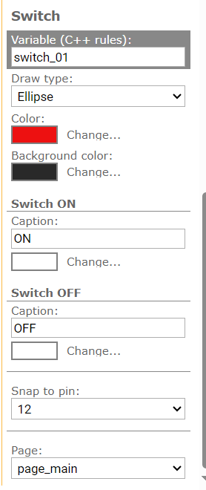
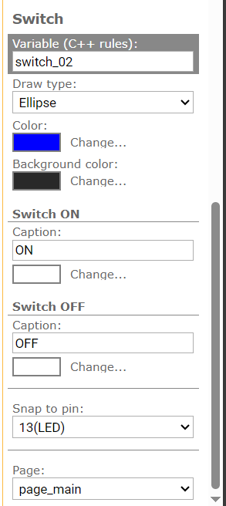

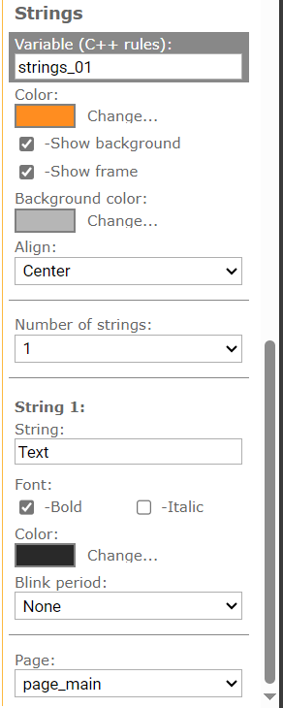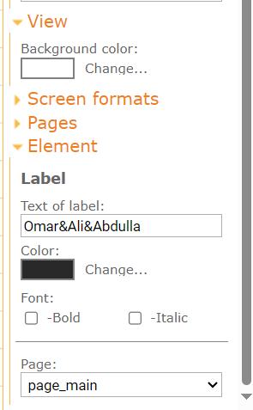
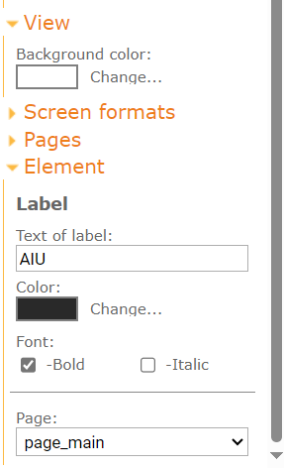
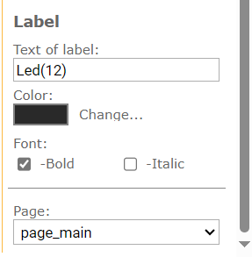

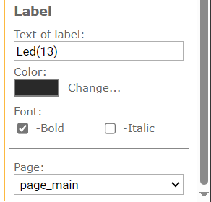

4- click get source code to get the code



How to connect mobile app
Go to remote xy app and from menu choose add new device then choose your device then choose the type of connection “Bluetooth” then the available devices appear chouse your device from them.
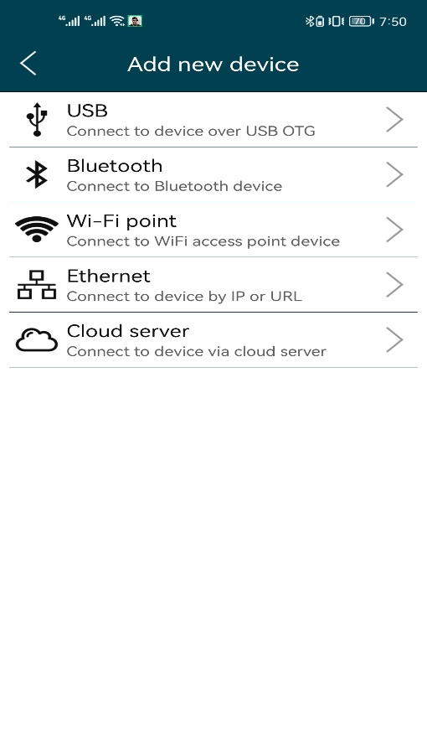
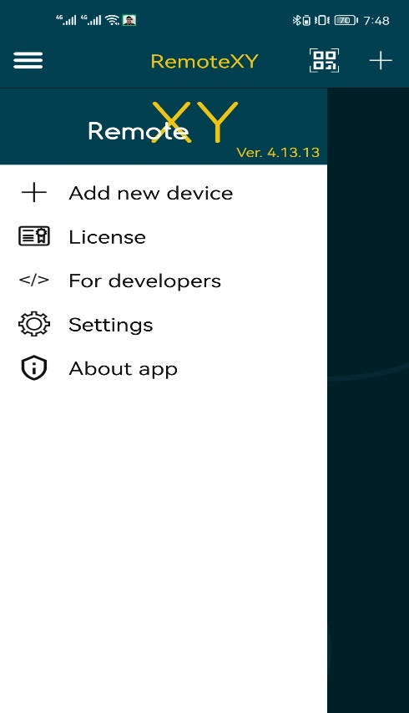

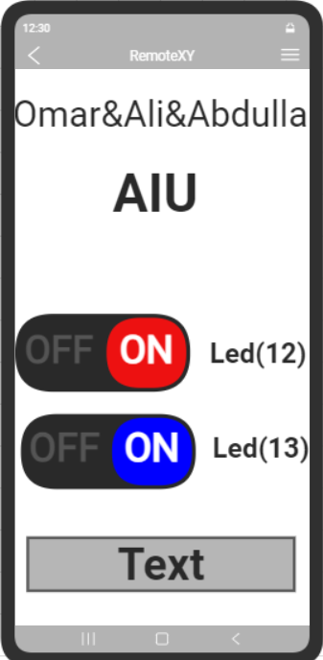

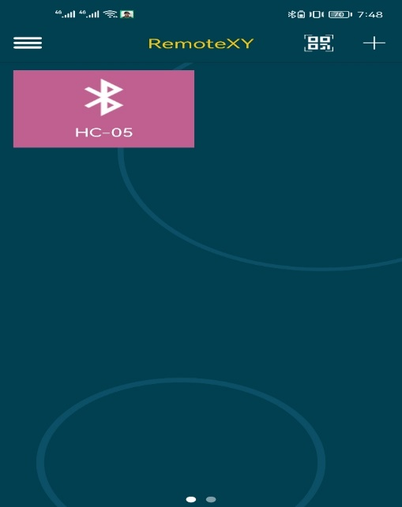

What to do After design:
1. Download the source code for board, open it in the Arduino IDE.
2. Install the RemoteXY library from the same page in remote xy website then go to Arduino IDE “add the library into Arduino app ->sketch->add library ->zip
3. Compile the source code and upload it to the board using the Arduino IDE.
4. Correctly connect HC-05 Bluetooth module to the board.
5. Install the mobile app RemoteXY to your phone or tablet.
6. Connect to board using mobile app -> add new device -> Bluetooth device.

Note: remote xy app is not free but there is a free version from the app which allow the user to connect only for 30s then the user need to reconnect again “if using more than 5 components”.

- - - - - - - - - - - - - - - - - - - - - - - - - - - - - - - - - - - - - - - - - - - - - - - - - - - - - - - - - - - - -

Source code:
/*
-- New project --

This source code of graphical user interface
has been generated automatically by RemoteXY editor.
To compile this code using RemoteXY library 3.1.13 or later version
download by link http://remotexy.com/en/library/
To connect using RemoteXY mobile app by link http://remotexy.com/en/download/
- for ANDROID 4.15.01 or later version;
- for iOS 1.12.1 or later version;

This source code is free software; you can redistribute it and/or
modify it under the terms of the GNU Lesser General Public
License as published by the Free Software Foundation; either
version 2.1 of the License, or (at your option) any later version.
*/

//////////////////////////////////////////////
// RemoteXY include library //
//////////////////////////////////////////////

// you can enable debug logging to Serial at 115200
//#define REMOTEXY__DEBUGLOG

// RemoteXY select connection mode and include library
#define REMOTEXY_MODE__SOFTSERIAL

#include <SoftwareSerial.h>

// RemoteXY connection settings
#define REMOTEXY_SERIAL_RX 10
#define REMOTEXY_SERIAL_TX 11
#define REMOTEXY_SERIAL_SPEED 9600

#include <RemoteXY.h>

// RemoteXY GUI configuration
#pragma pack(push, 1)
uint8_t RemoteXY_CONF[] = // 134 bytes
{ 255,2,0,1,0,127,0,19,0,0,0,0,31,1,106,200,1,1,7,0,
2,0,88,63,28,1,1,8,31,31,79,78,0,79,70,70,0,2,2,124,
63,27,1,204,8,31,31,79,78,0,79,70,70,0,129,255,11,107,13,0,
8,79,109,97,114,38,65,108,105,38,65,98,100,117,108,108,97,0,129,70,
98,35,10,64,8,76,101,100,40,49,50,41,0,129,71,132,35,10,64,8,
76,101,100,40,49,51,41,0,74,4,168,97,20,13,2,29,8,64,84,101,
120,116,0,129,35,37,30,19,64,8,65,73,85,0 };

// this structure defines all the variables and events of your control interface
struct {

// input variables
uint8_t switch_01; // =1 if switch ON and =0 if OFF
uint8_t switch_02; // =1 if switch ON and =0 if OFF

// output variables
uint8_t strings_01; // from 0 to 1

// other variable
uint8_t connect_flag; // =1 if wire connected, else =0

} RemoteXY;
#pragma pack(pop)

/////////////////////////////////////////////
// END RemoteXY include //
/////////////////////////////////////////////

#define PIN_SWITCH_01 12
#define PIN_SWITCH_02 13

void setup()
{
RemoteXY_Init ();
pinMode(9,INPUT);
pinMode (PIN_SWITCH_01, OUTPUT);
pinMode (PIN_SWITCH_02, OUTPUT);

// TODO you setup code

}

void loop()
{
RemoteXY_Handler ();

if (digitalRead(9)==HIGH)//if the bottom pressed
{ sprintf(RemoteXY. strings_01,"Maha Qubais");// write “Maha Qubais” in mobile app
Serial.print("Maha Qubais");
Serial.print('\n');
//delay(1000);
}
if (digitalRead(9)==LOW)// if not bottom pressed
{ sprintf(RemoteXY. strings_01,"2024/12/08");// write 2024/12/08in mobile app
Serial.print("2024/12/08");
Serial.print("\n");
//delay(1000);
}

digitalWrite(PIN_SWITCH_01, (RemoteXY.switch_01==0)?LOW:HIGH);
digitalWrite(PIN_SWITCH_02, (RemoteXY.switch_02==0)?LOW:HIGH);

// TODO you loop code
// use the RemoteXY structure for data transfer
// do not call delay(), use instead RemoteXY_delay()
}

Conclusion:
The Bluetooth-based LED control project using the Remote XY app wireless to control of LEDs' on/off state. Additionally, the we have a physical push button with the Arduino allowed for manual control of the displayed text on the Remote XY app. We can easily change the LEDs' status from our smartphones. By combining Bluetooth communication, mobile app integration, and physical input, the project showed how flexible is
The Arduino-based systems.

References:

1. Remote XY Website - Official website for Remote XY, where we can create customized interfaces and generate source code:
(https://www.remotexy.com)
2. Arduino - website “ you can download Arduino app from this site ”:
(https://www.arduino.cc)

